Exercise 1: Logging Error Messages and Warning Levels

1. Adding SLF4J and Logback dependencies to the `pom.xml` file

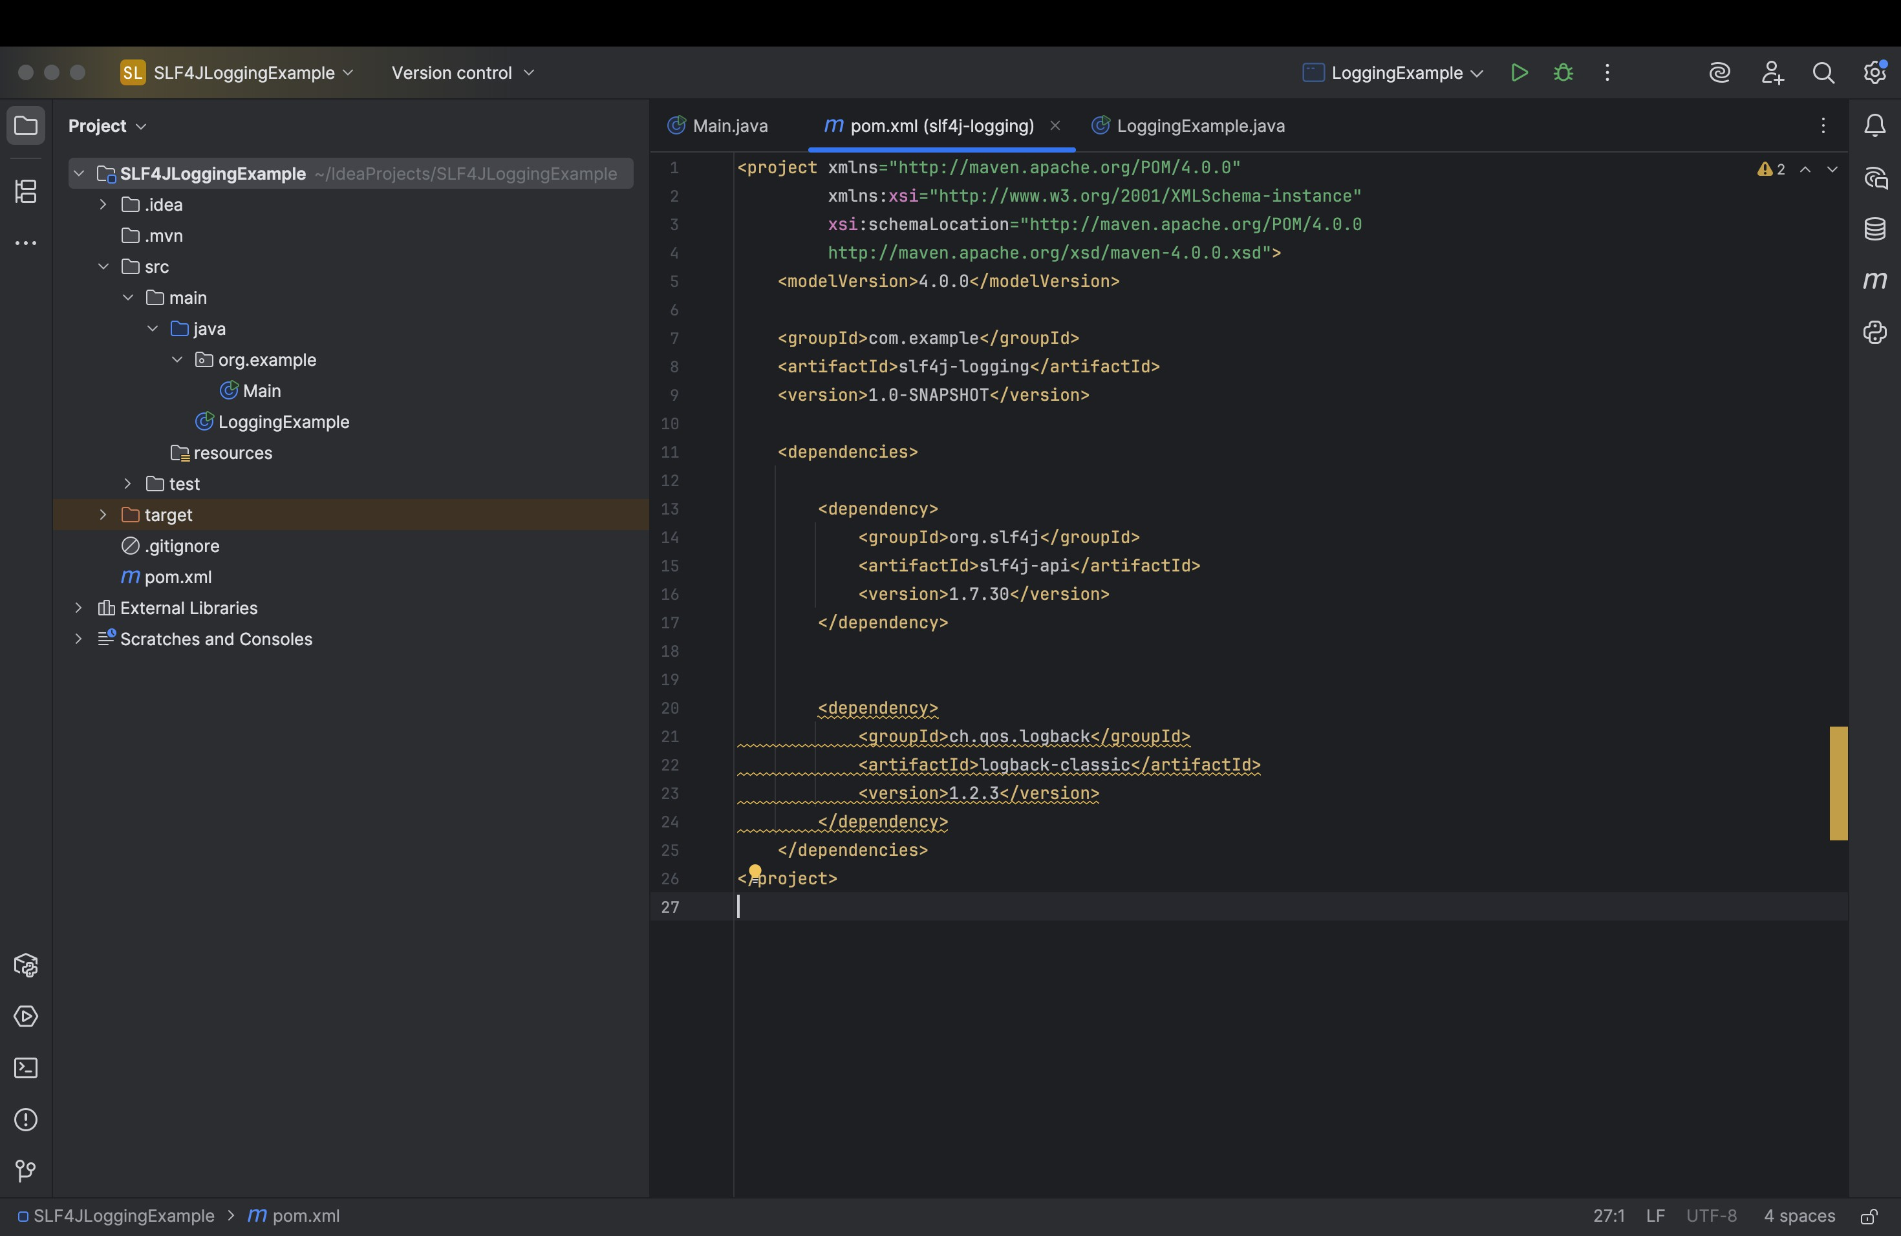

1. Created a Java class that uses SLF4J for logging

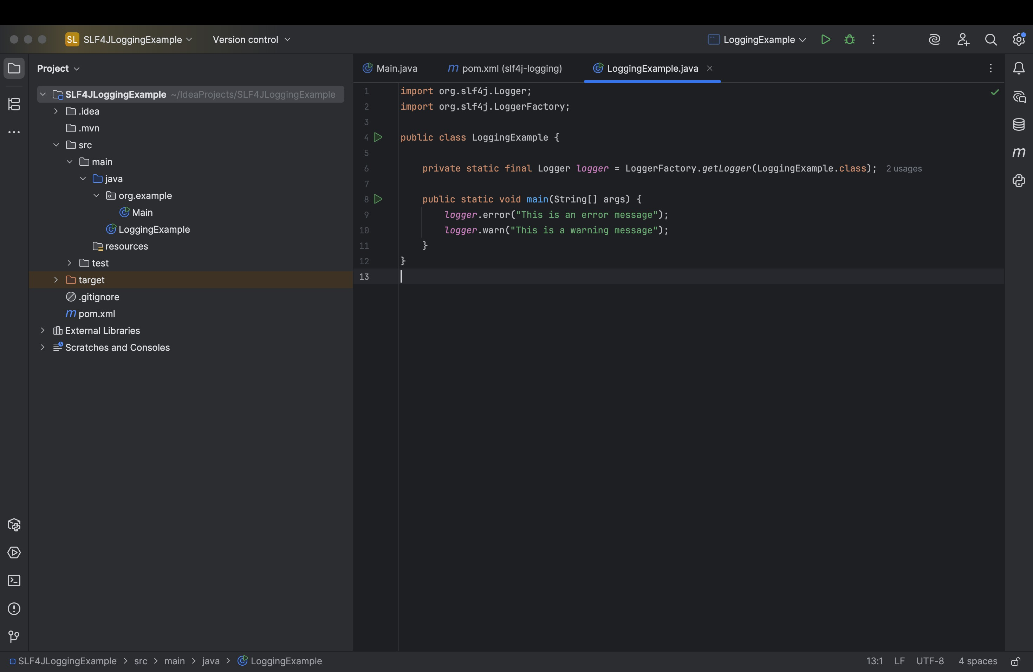

Output:-

